Unit Code Coverage for Assembly with LDRA Toolsuite (for Carlake)

Author: Chandhini K

* Double click .exe to start the installation. Install as an administrator

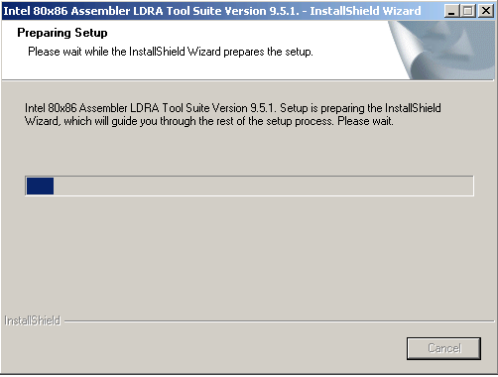

* Click Yes

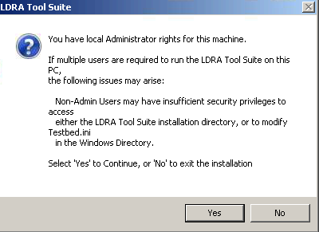

* Click Next

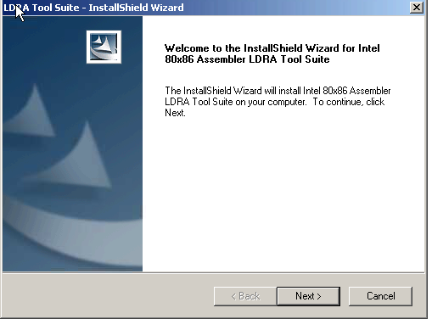

* Choose Standard Workstation and click Next

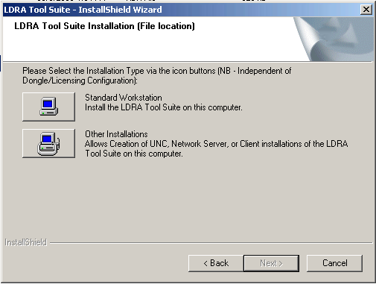

* Choose Typical and click Next

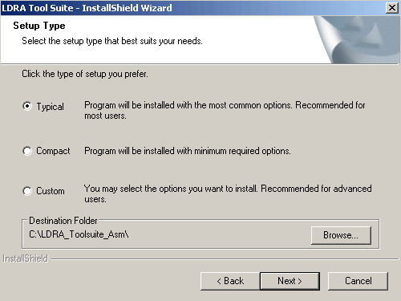

* Choose **Classic settings** and click Next

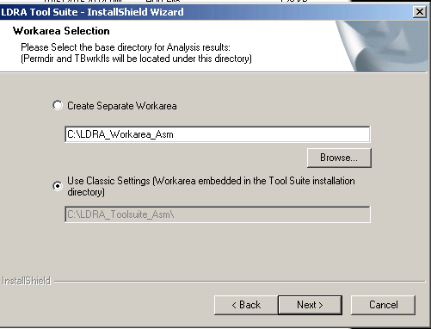

* Click Next

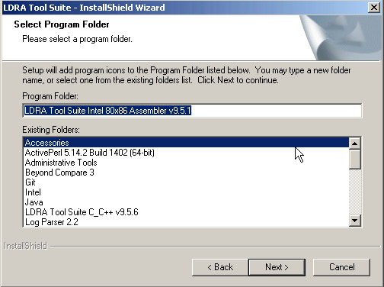

* Continue by clicking Next

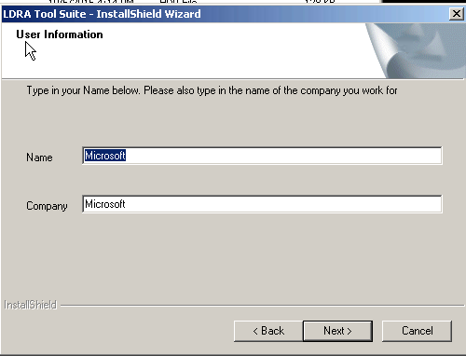

* Click Next

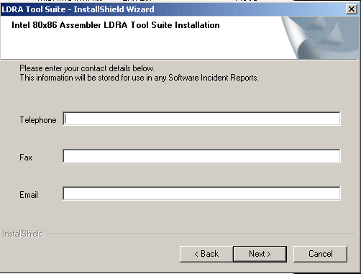

* Click Next

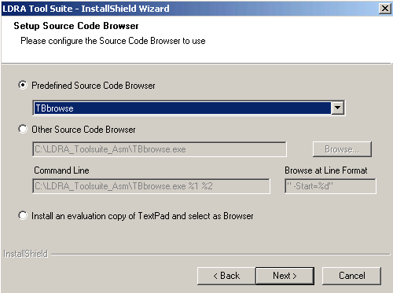

* Continue by clicking Next

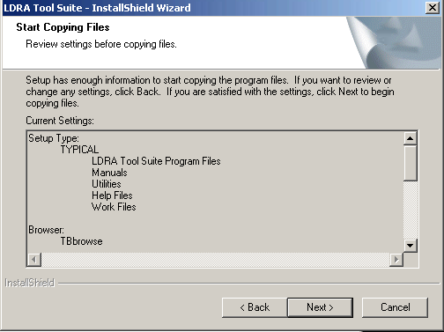

* Installation starts

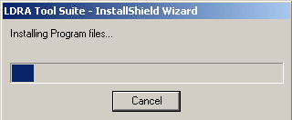

* Click Finish

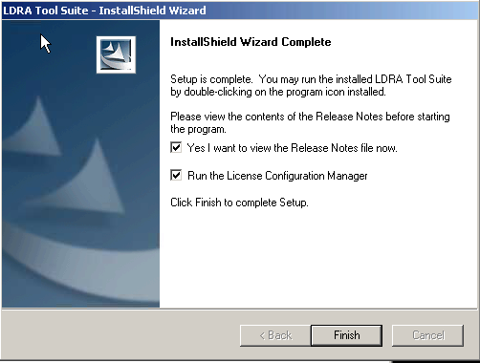

* There should be Intel 80x86 Assembler LDRA Testbed(9.5.1) in Select Installation dropdown in LDRA Launcher

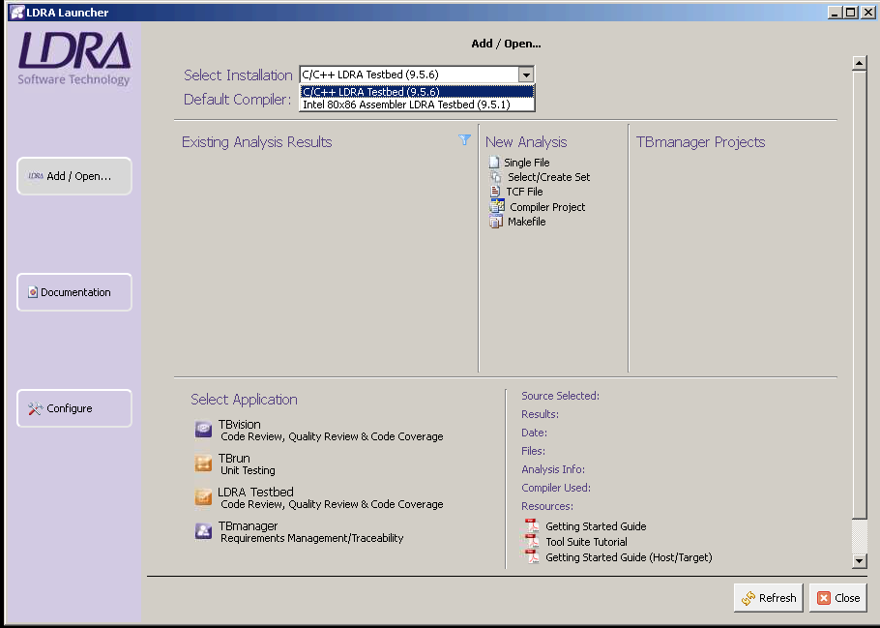

1. Create a *.c wrapper file for each of the *.sx file. The *.c file will contain the name of the function available in the *.sx file that need to be analyze.

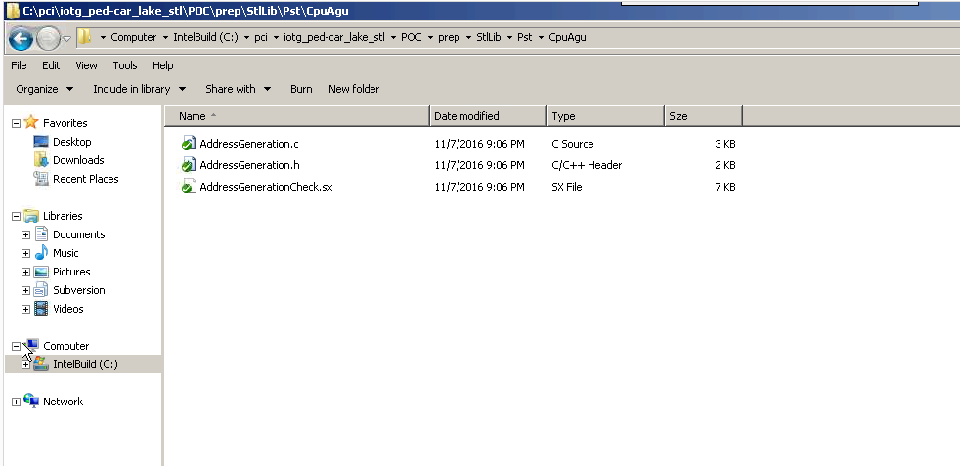

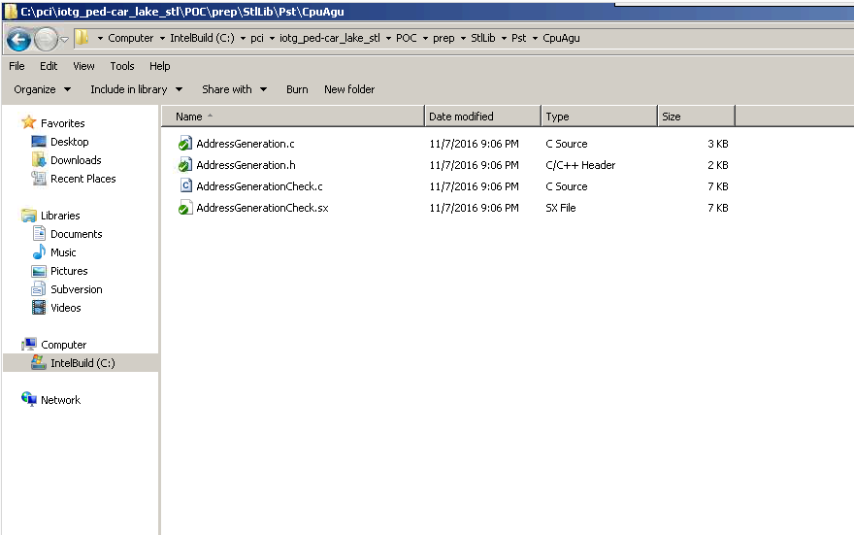

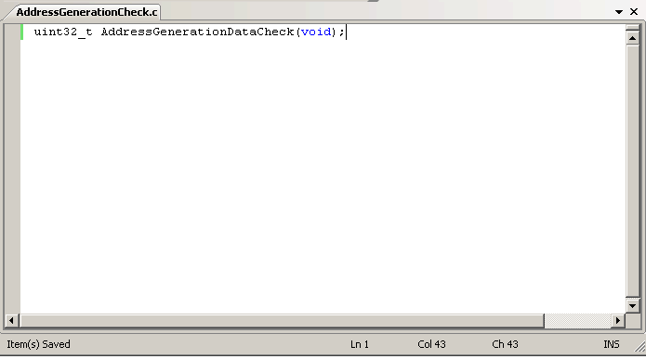

2. Open LDRALauncher

3. Open LDRA Testbed . Go to Analysis and select Object Code Verification Phase Active.

5. Close LDRA Testbed

6. Open TBrun

7. Go to Source > Single file…

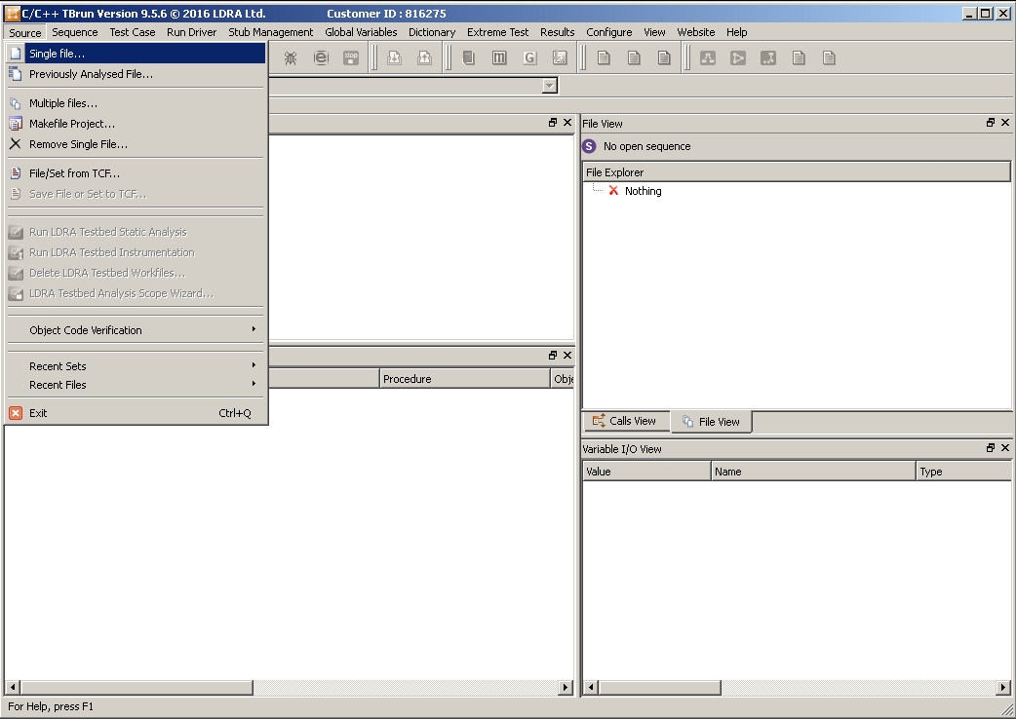

8. Select the *.c wrapper file.

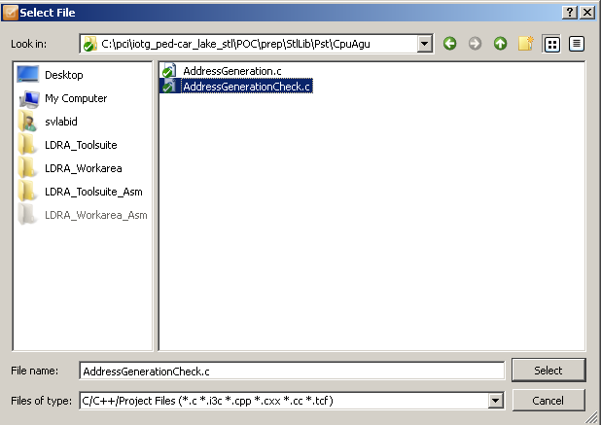

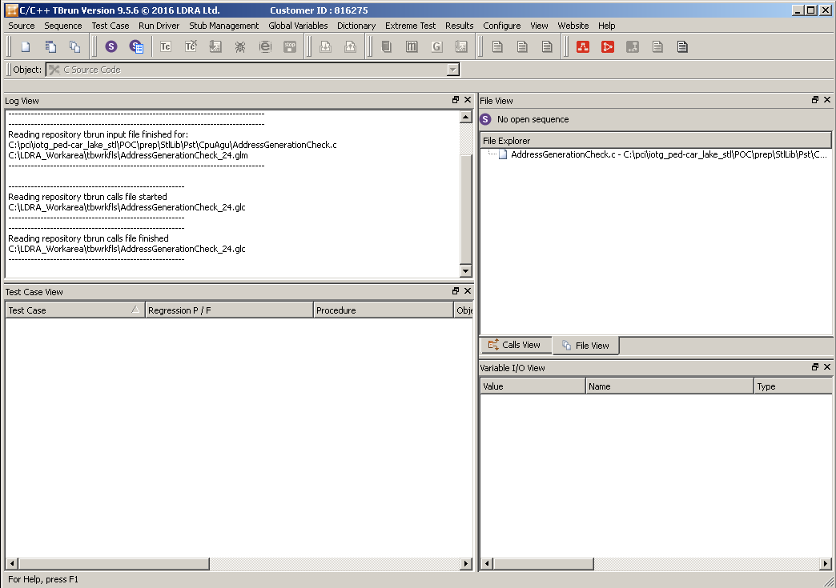

9. Go to Sequence > New…

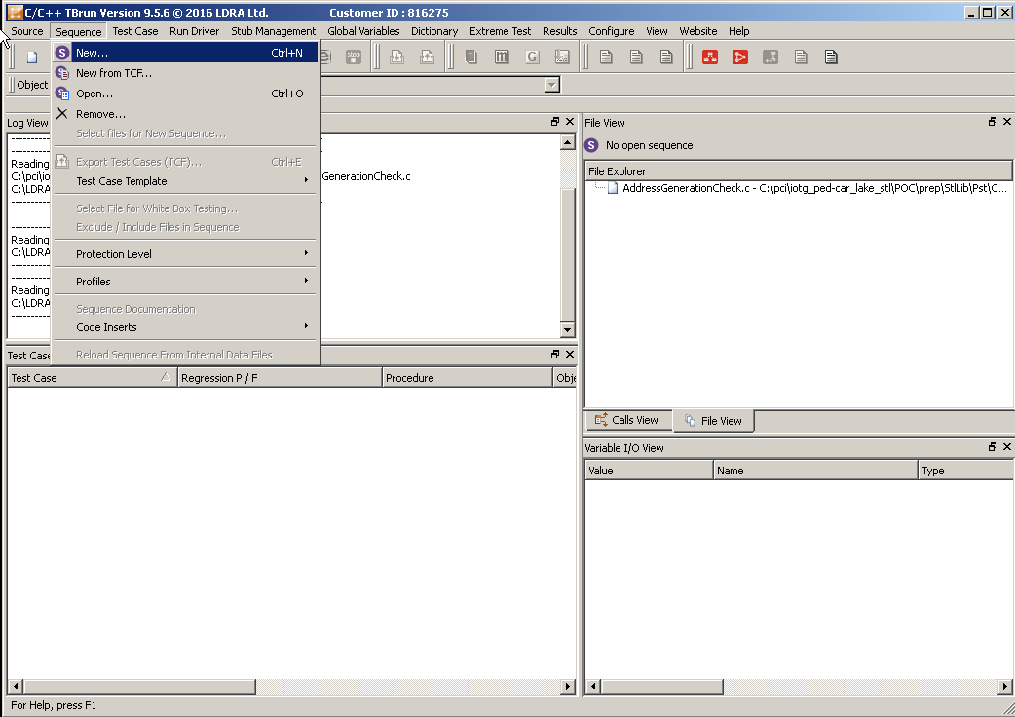

10. Give a name to the new sequence in Sequence Name field and click Continue.

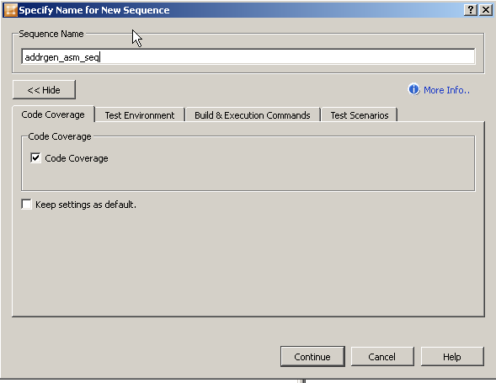

11. Double click at the *.c file in File Explorer and the Select Active Profile window will prompt.

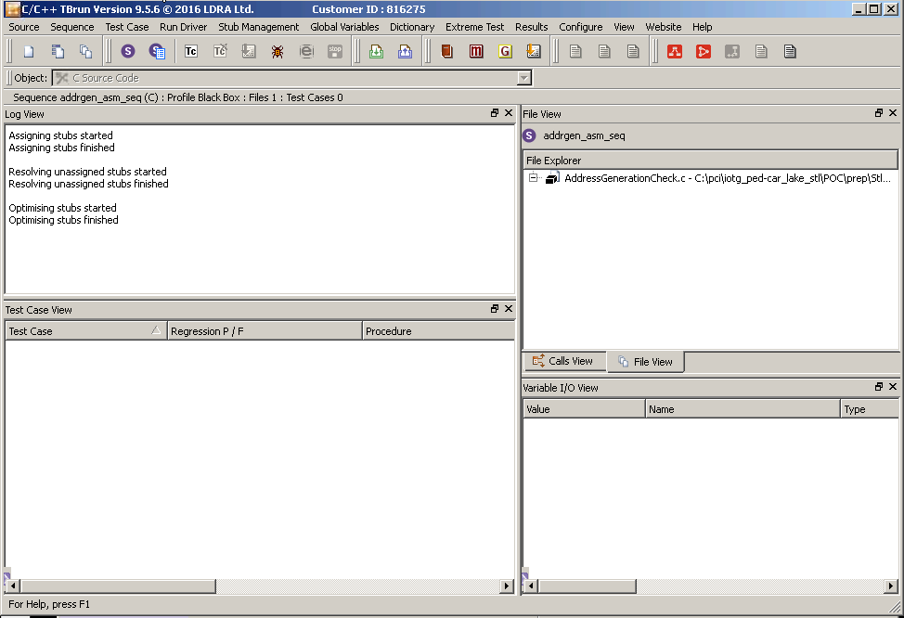

12. Select Assembly Test with Coverage and click OK.

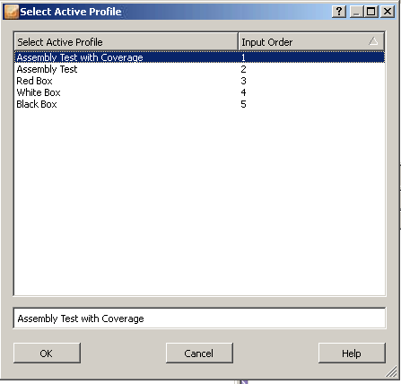

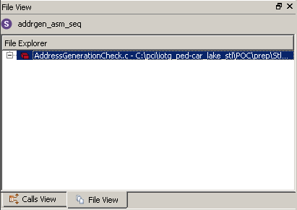

13. Right click at the *.c file in File Explorer and the Select Code Inserts 🡪 View\Edit Include Code

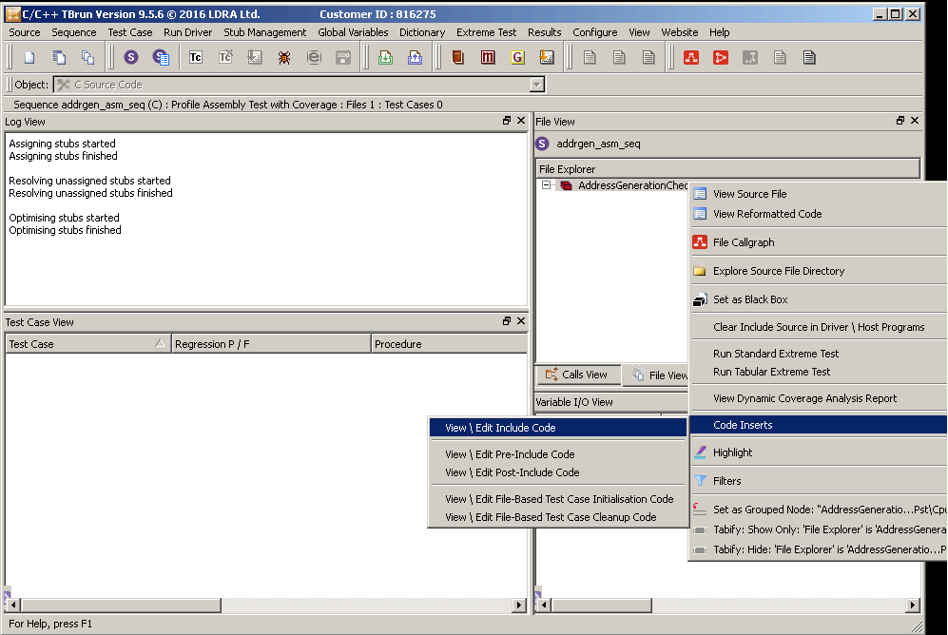

14. Enter the following code and Click OK

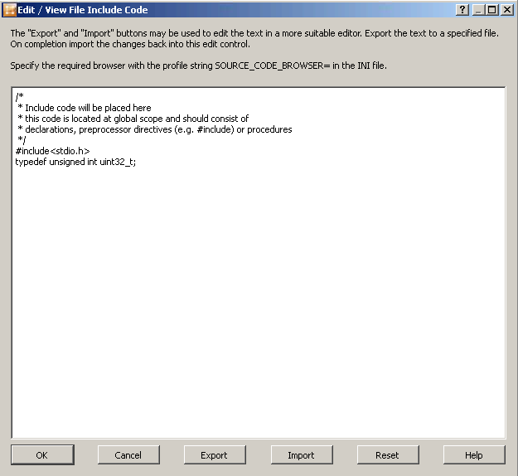

15. Go to Test Case > Create Specialised Test Case > Create New Test Case for Unanalysed Procedure and a window will prompt.

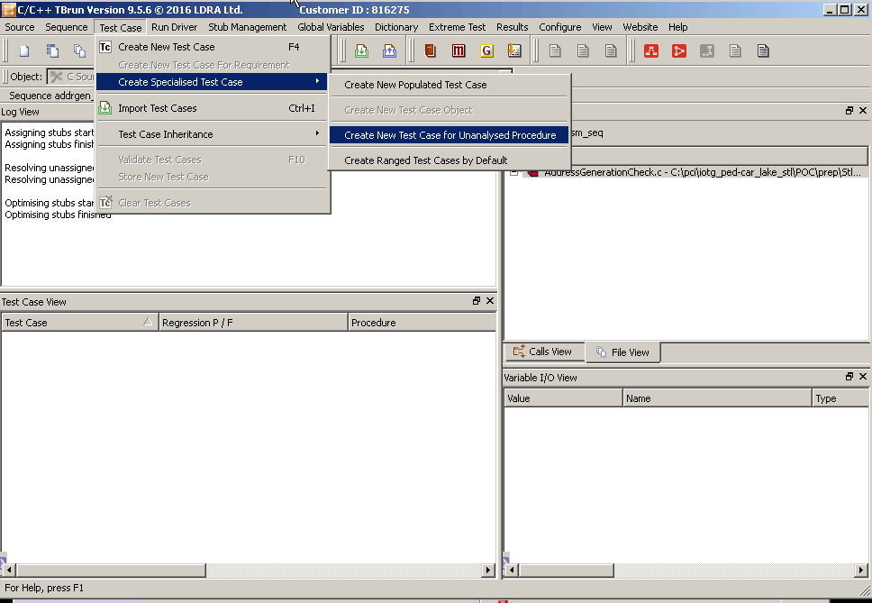

16. From the dropdown menu, select the name of the function to be analyzed and click Finish.

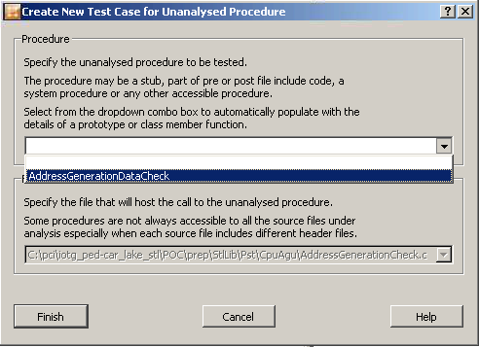

17. Go to Run Driver > Run Driver. Make sure that there are no error message from Log View before proceed to the next step.

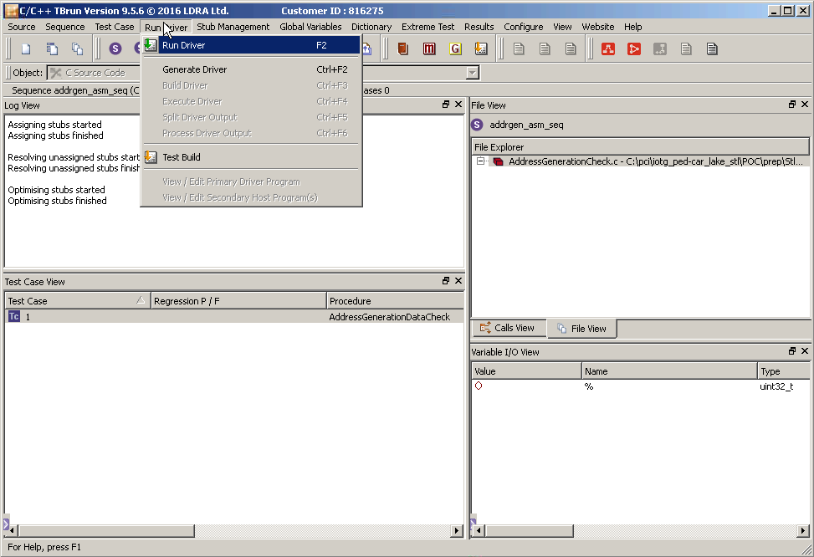

* Check that it passes Click OK to accept this test case

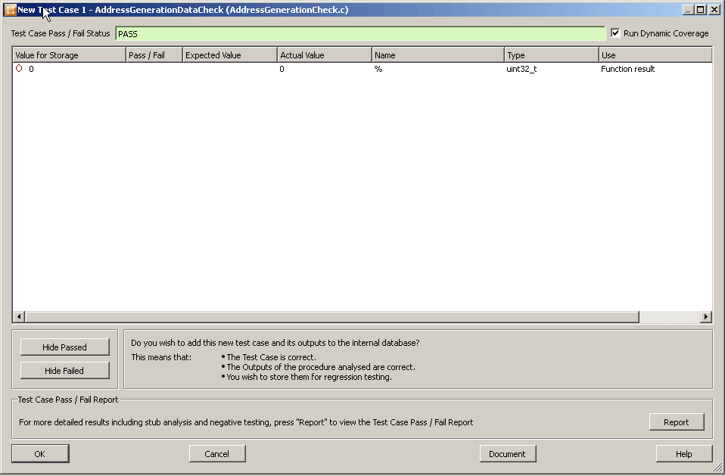

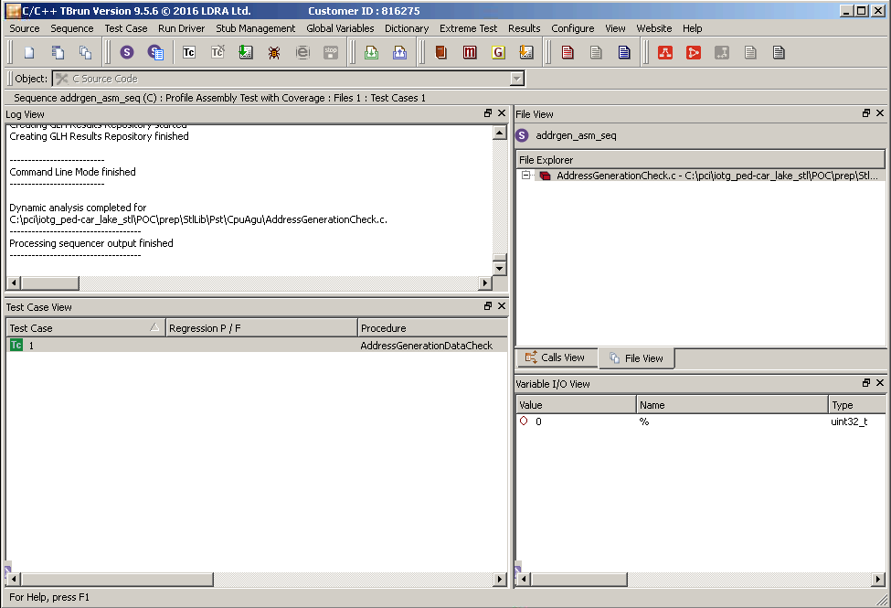

* To see the report. Select Results🡪Dynamic Coverage Analysis Report

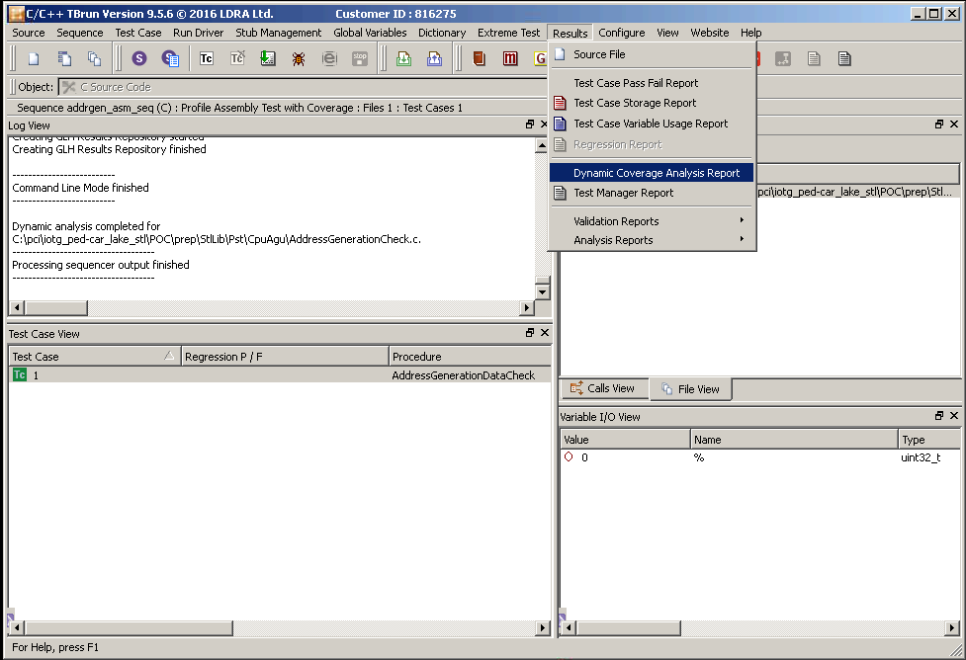

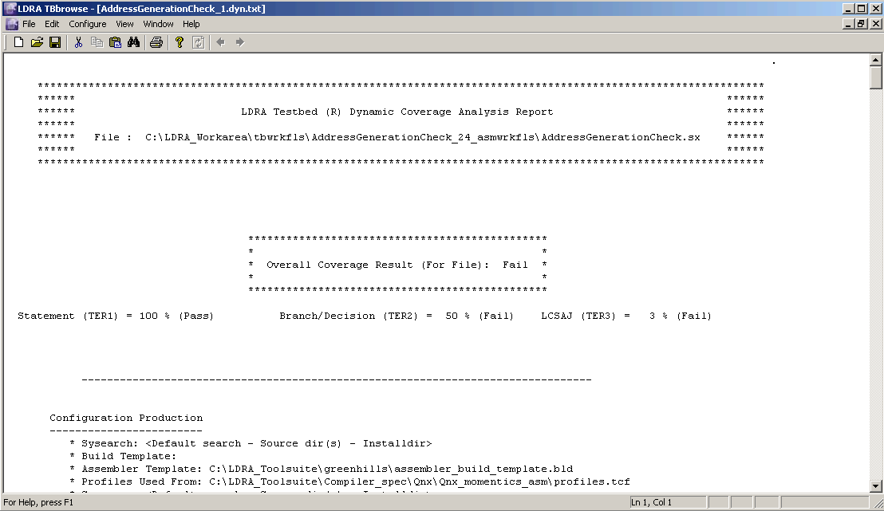

Go to Run Driver > Generate Driver. Make sure that there are no error message from Log View before proceed to the next step.

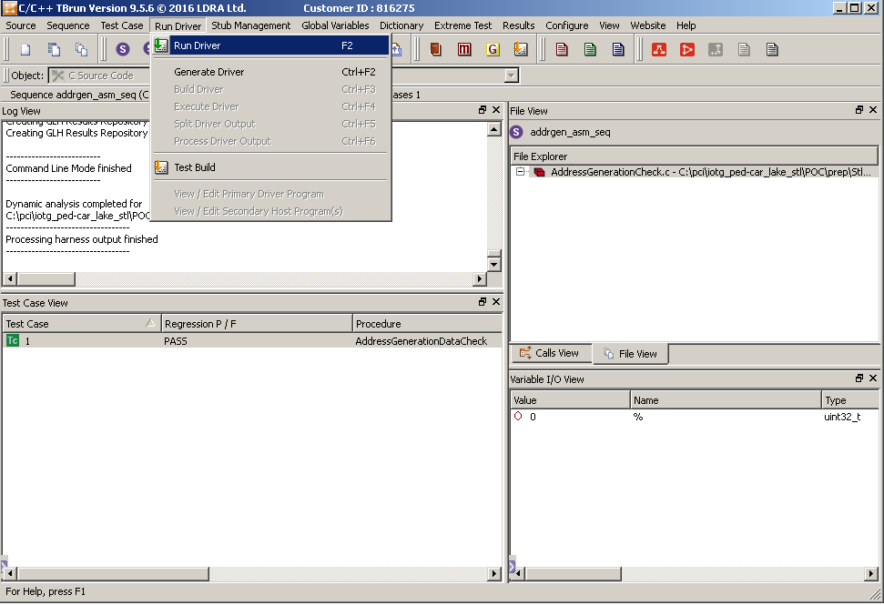

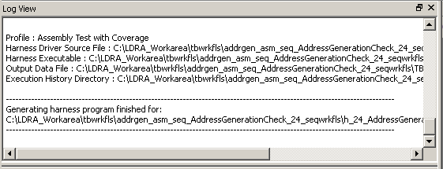

Go to Configure > Driver Build & Execution Options. A window will prompt.

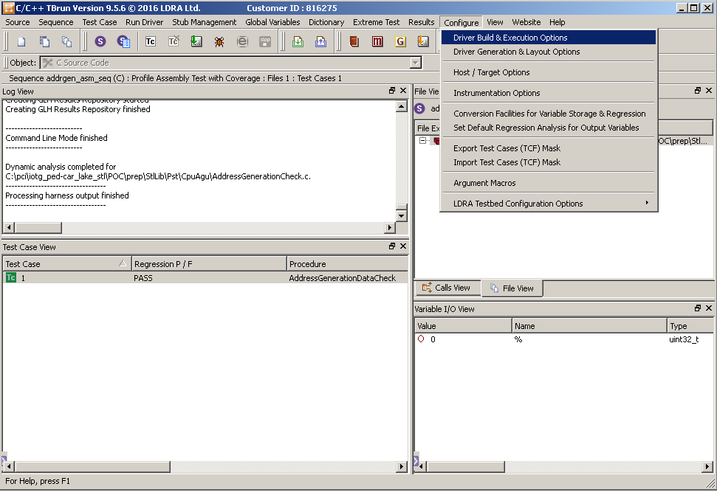

In the Build Command field, edit $(ObjBoxAsmSourceDir) inszt_*.$(ObjBoxAsmSourceExt) to $(ObjBoxAsmSourceDir) inszt_*mod.$(ObjBoxAsmSourceExt).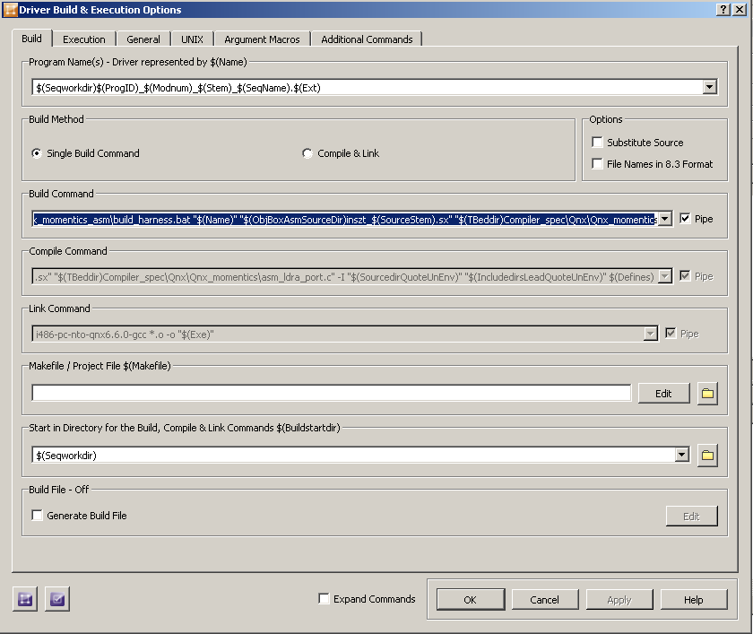

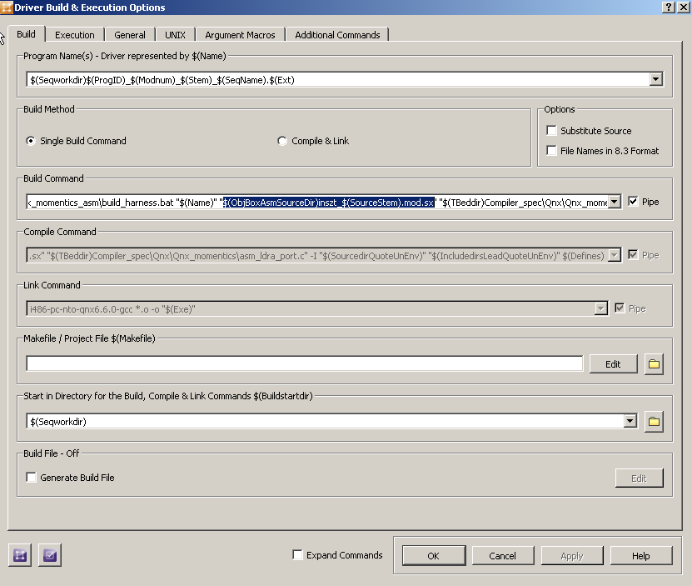

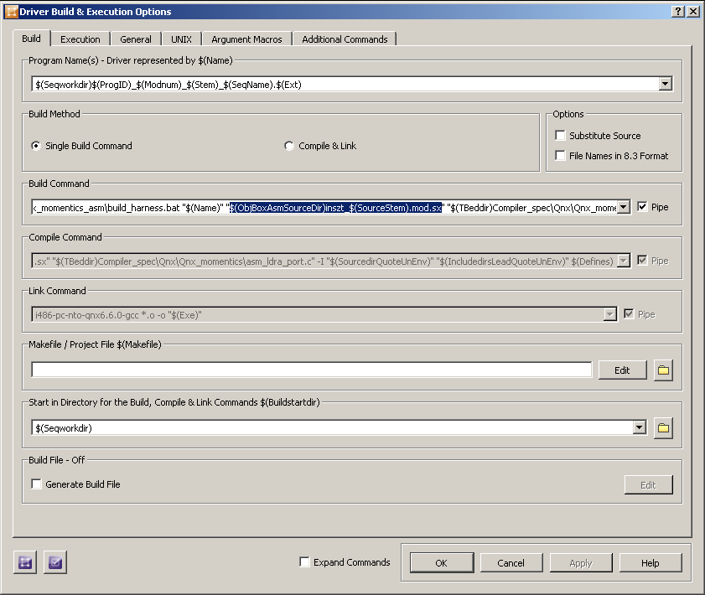

Now go to the directory where the instrumented code of the *.sx is generated. Rename the instrumented file as below.

inszt_GeneralPurposeRegistersCheck.sx 🡪 inszt_GeneralPurposeRegistersCheck.mod.sx

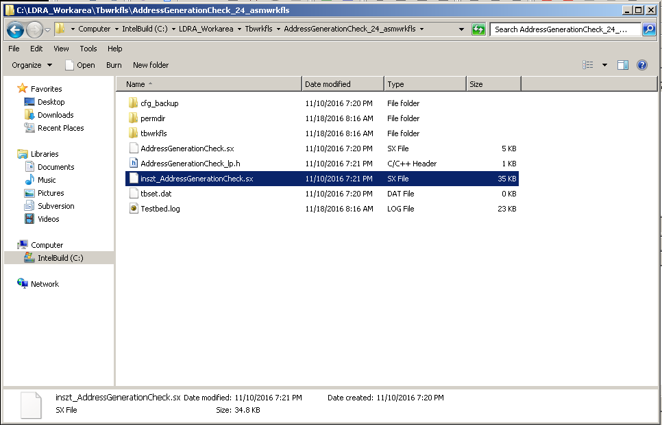

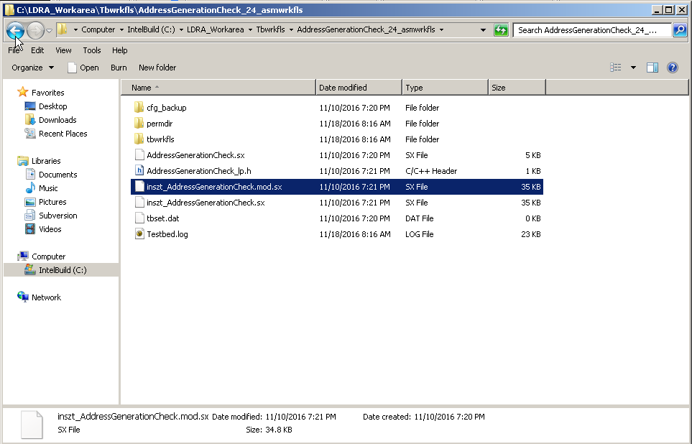

Open up the instrumented file and add the appropriate instruction before every available compare instruction. Once done, save the file.

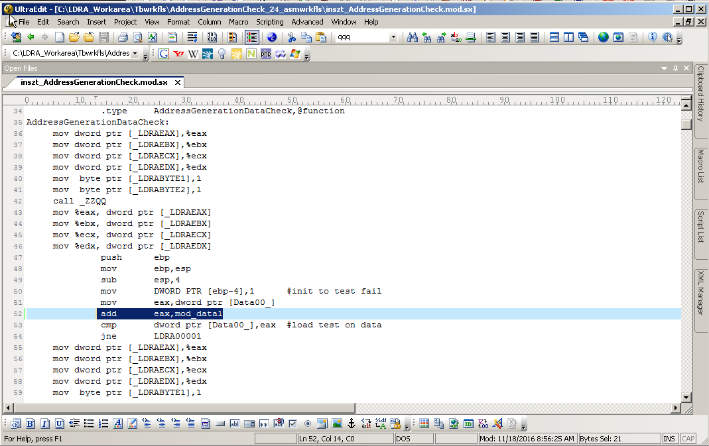

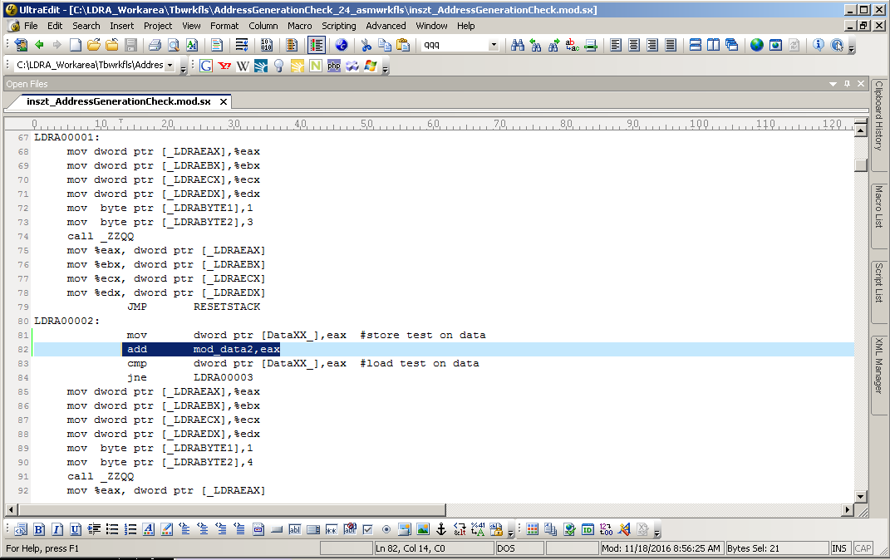

Go to Global Variables > Create User Global and the User Global Details window will prompt.

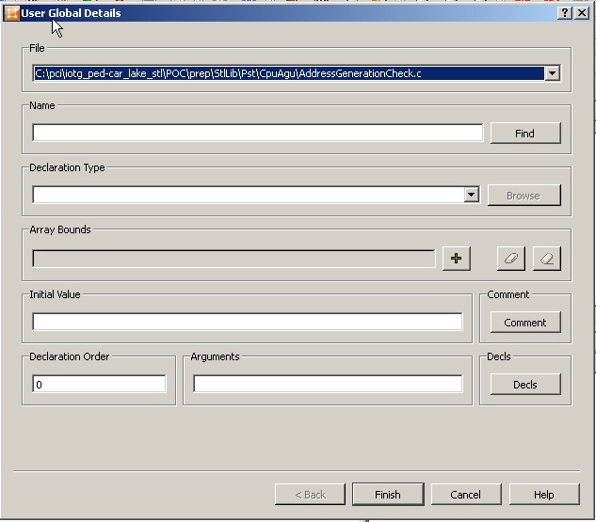

Fill in the Name, Declaration Type and Initial Value fields accordingly based from the variables added in the instrumented file in step 19 and click Finish. Repeat as needed.

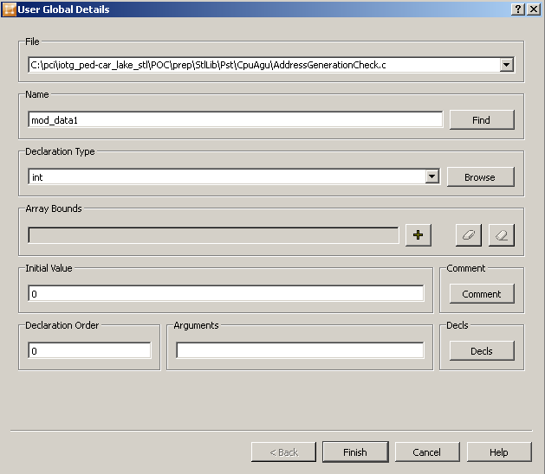

Right click at Variable I/O View and select Create IO Variable in Test Case.

Fill in the Name, Type and Value based from step 21 and select Input Global from the Use dropdown menu. Click OK.

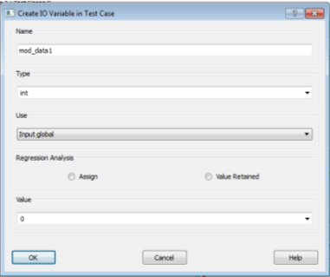

Go to Run Driver > Build Driver. Make sure that there are no error message from Log View before proceed to the next step.

Go to Run Driver > Execute Driver. Make sure that there are no error message from Log View before proceed to the next step.

Go to Run Driver > Split Driver Output. Make sure that there are no error message from Log View before proceed to the next step.

Go to Run Driver > Process Driver Output. Make sure that there are no error message from Log View before proceed to the next step.

Go to Results > Dynamic Coverage Analysis Report to view the results log.